|  |  |
| --- | --- |
| (BOARD GAME) Database  Using Oracle Apex | Instructor  Rawan AlMakinah  Project Team  Farah Alsubaheen Ghaida Alsugaiir Layan Alsamhan Manar Albader Mozn Alzunidi |

Table of Contents

Project Definition 2

Customer Requirements 2

Mission Statement 2

Database Objectives 2

Database Description 2

Database Tables 3

Base Tables 3

Linking Tables 3

Views Tables 3

Entity Relationship Diagram (ERD) 4

SQL Queries 5

Creating Base / linking Tables 5

Base / linking Tables Insertion 6

Views Tables 7

General Queries 8

Software and Tools 10

References 10

# Project Definition

## Customer Requirements

## the game company requires a database that is capable of storing and accessing user IDs, names, passwords, levels, emails, genders, game IDs, game names, game descriptions, maximum and minimum players, difficulty levels, room IDs, room names, results IDs, results names, scores, start and end time records, reward IDs, reward names, level, prizes, and descriptions. The database should also be capable of updating user logins and logouts and recording game results, including score, start time, and end time. All of the information should be retrievable from the database. And it should be known that each game ends up with one result.

## Mission Statement

## Our mission is to develop a comprehensive database for a new board game that is able to keep track of user and game information, as well as room and result data, in order to provide an enjoyable and easy-to-access experience for players.

## Database Objectives

* To provide easy and secure access to user and game information for creating accounts and managing gameplay.
* To enable users to log in and out of the system securely and efficiently.
* To store and track room data, allowing for efficient management of game sessions.
* To record and store game results, including score, start and end time.
* To allow for fast and accurate data retrieval and analysis.

## Database Description

The Board game database is designed to cover the needs of collecting and organizing data of the players and the game properties. The database has 5 **base tables**, 2 **linking tables**, and 1 **view** listed in the following sections. Each table has a role in achieving one of the mentioned objectives above. Using these tables and views by applying suitable queries, the user of the database will be able to:

* Easier and safer access for both the user and the game administrator.
* System and security in user login and logout.
* Manage the game effectively by storing and tracking room data.
* Store the score and start and end times for each game.
* Analyze and retrieve data quickly and accurately.

# Database Tables

## Base Tables

1. **Logs table:** it has 4 attributes(log_id/login_time/logout_time/user_id) the use of this table is to create more security for players where it saves all the log and time of each player.
2. **User1 table:** it has 6 attributes (user_id/user_name/user_password/user_email/user_level/

User_gander) the use of this table is to save the player information for future purposes as to calculate and save the process of each player.

1. **Room _information table:** it has 2 attributes(room_id/room_name) the use of this table is to have a virtual room players can share with friends and family and play together.
2. **Game_itself table:** it has7 attributes (game_id/game_name/game_description/

game_duration /game_max_users/game_min_users/game_defficulty level) the use of this table is to save all games information as to what is the game, how many is allowed in one game, how long each game takes and the levels on each game.

1. **Reward table**: it has 5 attributes (reward_id / reward_name / reward_level /

reward_description /reward_prize) the use of this table is to have a different prize for each level the player reaches as to what is the name of it, in what level the player can get it and what exactly is the prize.

## Linking Tables

1. **Room table:** it has 4 attributes(room_code/game_id/room_id/user_id) the use of this table is when a player chooses a game and a room with friends or family to play with other players around the world.
2. **Results table:** it has 6 attributes (result_id / result_score / result_start_time /

result_end_time /reward_id/room_code) the use of this table is to collect and show the final results of a game as to when it started, ended, what room and score did players get.

## Views Tables

1. The columns from the **Results, Room, and Game tables** such as game_name and score are included in the view table through joining them together. As requested: an inner join between them is used, and the common columns shared by the two tables, like room_id, will be specified in order to link the tables. Through this view table, information such as game name and score or other relevant data can be easily queried.

# Entity Relationship Diagram (ERD)

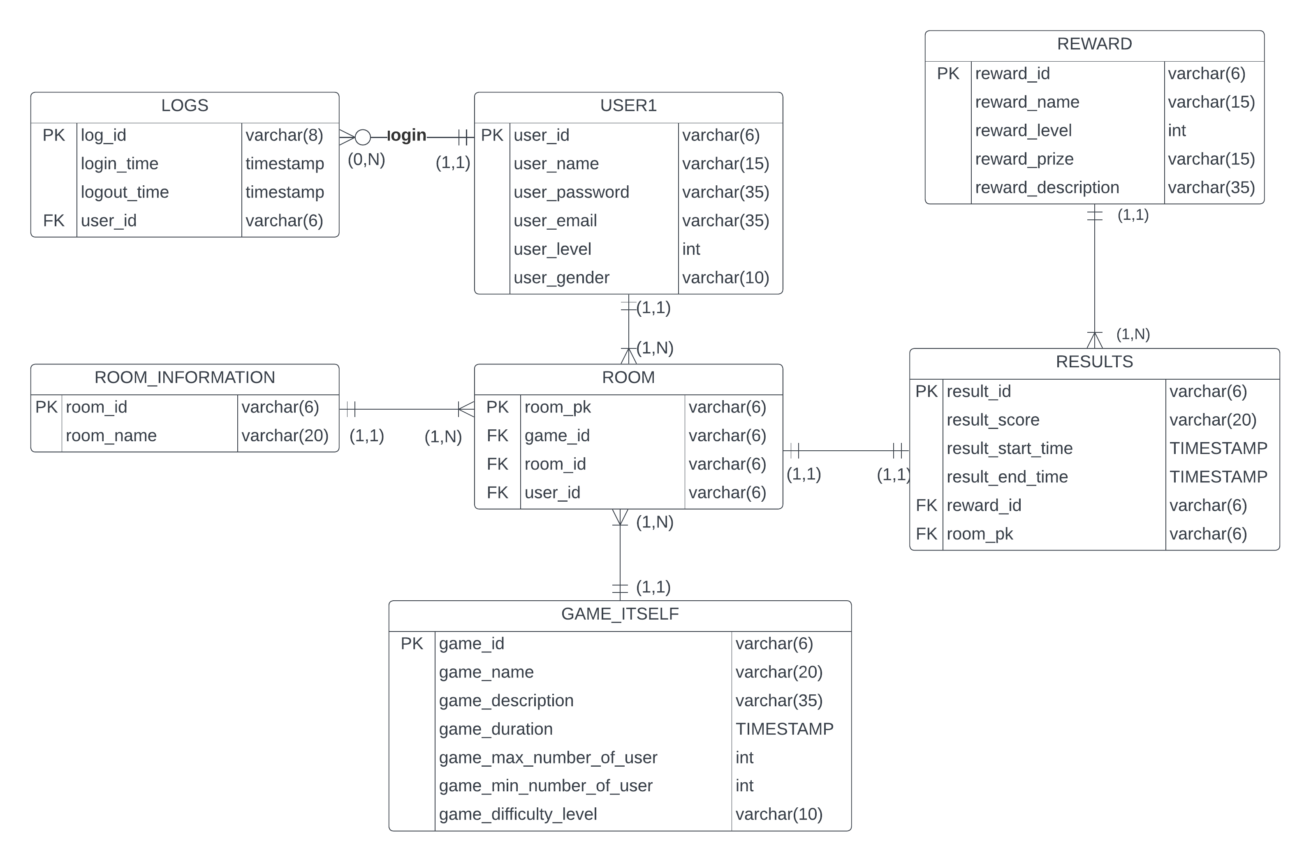

# SQL Queries

## A screenshot of a computer Description automatically generatedA screenshot of a computer Description automatically generated with medium confidenceA screenshot of a computer Description automatically generatedA screenshot of a computer Description automatically generated with medium confidenceA screenshot of a computer Description automatically generated with medium confidenceCreating Base / linking Tables

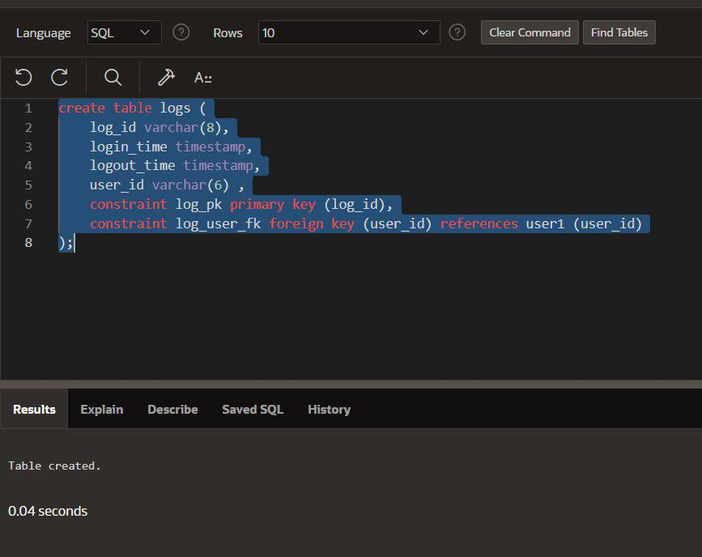

## A screenshot of a computer Description automatically generatedA screenshot of a computer Description automatically generatedA screenshot of a computer Description automatically generatedA screenshot of a computer Description automatically generatedA screenshot of a computer Description automatically generatedA screenshot of a computer Description automatically generatedA screenshot of a computer Description automatically generatedA screenshot of a computer Description automatically generatedA screenshot of a computer Description automatically generatedA screenshot of a computer Description automatically generatedA screenshot of a computer Description automatically generated with medium confidenceA screenshot of a computer Description automatically generated with medium confidenceA screenshot of a computer Description automatically generated with medium confidenceA screenshot of a computer Description automatically generatedA screenshot of a computer Description automatically generated with medium confidenceA screenshot of a computer Description automatically generated with medium confidenceA screenshot of a computer Description automatically generated with medium confidenceA screenshot of a computer Description automatically generated with medium confidenceA screenshot of a computer Description automatically generatedBase / linking Tables Insertion

## Views Tables

## 

## General Queries

|  |  |
| --- | --- |
|  |  |
|  |  |
|  |  |
|  | |

|  |
| --- |
|  |
|  |
|  |
|  |

# Software and Tools

1. APEX
2. Lucidchart
3. Microsoft Word

# References

1. w3schools
2. medium
3. ChatGPT
4. Javatpoint
5. Oracle tutorials
6. bytescout